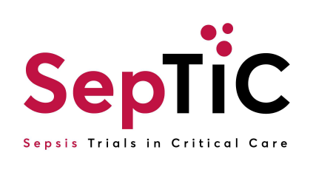
SepTiC Sealed Envelope (Unblinded Pharmacist) Training Log
Instructions for Sites and Users
- Unblinded pharmacists must first complete the SepTiC Sealed Envelope for Unblinded Pharmacist Training
- The Unblinded Pharmacist will then complete this form to confirm that the Unblinded Pharmacist Training has been received and understood.
- Unblinded Pharmacist must sign a User Acceptance Form to gain access to Sealed Envelope for kit allocation and viewing unblinded allocations.
- An email from Sealed Envelope with a link to the study will be generated and sent to each user.
- Users should check their spam emails and add Sealed Envelope to the safe-senders list.

Study Name | Sepsis Trials in Critical Care (SepTiC) | Investigator Name
Site Staff Full Name (Print): |  | Site Number
Name of document | Version and date of documents trained on | Date training completed by Unblinded Pharmacist | Signature of Unblinded Pharmacist
Sealed Envelope for Unblinded Pharmacist | Version: ____________  Date: ______________
SepTiC Protocol | Version: ____________  Date: ______________
IMP Handling Manual | Version: ____________  Date: ______________
IMP Management Plan | Version: ____________  Date: ______________
Sargramostim Investigators Brochure | Version: ____________  Date: ______________

- Signatures must be electronic or in wet ink, images of signatures cannot be accepted.
- I confirm that I have received, reviewed and understood the Sealed Envelope for Unblinded Pharmacist Training.

