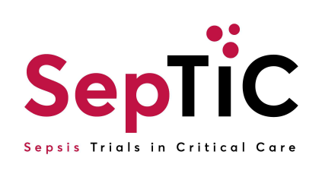

**IMP Administration Training Log**

|  |
| --- |
| **Instructions for Sites** |
| 1. A site staff member whose usual clinical role is to administer medication to patients (including via a subcutaneous injection), may administer the IMP for SepTiC patients once points 2 and 3 are completed. 2. Site staff administering IMP for SepTiC must first complete the IMP Administration Training Slides 3. The site staff member must complete this form to confirm that the IMP Administration Training has been received and understood. |

|  |  |  |  |
| --- | --- | --- | --- |
| **Study Name** | Sepsis Trials in Critical Care (SepTiC) | **Investigator Name** |  |
| **Site Name** |  | **Site Number** |  |

* **Signatures must be electronic or in wet ink, images of signatures cannot be accepted**.
* **I confirm that I have received, reviewed and understood the IMP Administration Training.**

|  |  |  |  |
| --- | --- | --- | --- |
| **Site Staff Full Name (Print):** | **Date of Administration Training & Version** | **Signature of site member** | **Date of Training** |
|  | **Version** |  |  |
| **Date** |
|  | **Version** |  |  |
| **Date** |
|  | **Version** |  |  |
| **Date** |
|  | **Version** |  |  |
| **Date** |
| **Site Staff Full Name (Print):** | **Date of Administration Training & Version** | **Signature of site member** | **Date of Training** |
|  | **Version** |  |  |
| **Date** |
|  | **Version** |  |  |
| **Date** |
|  | **Version** |  |  |
| **Date** |
|  | **Version** |  |  |
| **Date** |
|  | **Version** |  |  |
| **Date** |
|  | **Version** |  |  |
| **Date** |
|  | **Version** |  |  |
| **Date** |
|  | **Version** |  |  |
| **Date** |
|  | **Version** |  |  |
| **Date** |
|  | **Version** |  |  |
| **Date** |
|  | **Version** |  |  |
| **Date** |
|  | **Version** |  |  |
| **Date** |
|  | **Version** |  |  |
| **Date** |
|  | **Version** |  |  |
| **Date** |